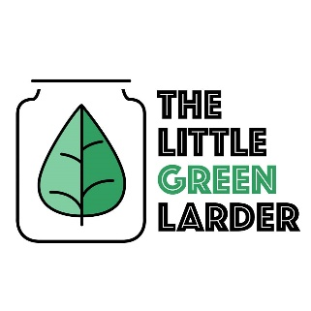

The Little Green Larder

Vegan chilli, guac + pearl couscous

Serves 2

Chilli ingredients Guacamole ingredients  
Chopped tomatoes Tomato  
¾ Onion Avocado  
Pepper 1 – 2 cloves garlic  
Bean mix, TVP mince Lime   
Chick peas ½ Chilli  
½ chilli ¼ onion  
Spice mix  
2 – 4 cloves garlic  
Pearl couscous

- Soak bean mix for 4 – 8hours (we just leave them overnight), rinse then place in a pot of water. Bring to boil then simmer for 1 hour. Drain and set aside. Soak TVP mince for 10 mins, drain + set aside.

- Chop onion, 4 - 6 cloves of garlic, chilli and pepper. fry 2 – 4 cloves garlic, 3/4 onion and spices in oil for 2 – 4 minutes. (add ½ chilli for extra spice) Add pepper and fry for a further 5 minutes.

- Add TVP mince and bean mix and the can of chopped tomatoes, cook for 20 – 30 minutes, salt and pepper to taste and serve with couscous.

- for guacamole mash avocado, mix with 1 – 2 garlic cloves, ¼ of the onion, chopped fresh tomatoes, the other ½ of the chilli and squeeze ½ of the lime juice in. Salt and pepper to taste.